Brad Farfaglia

CS 330 Milestone One

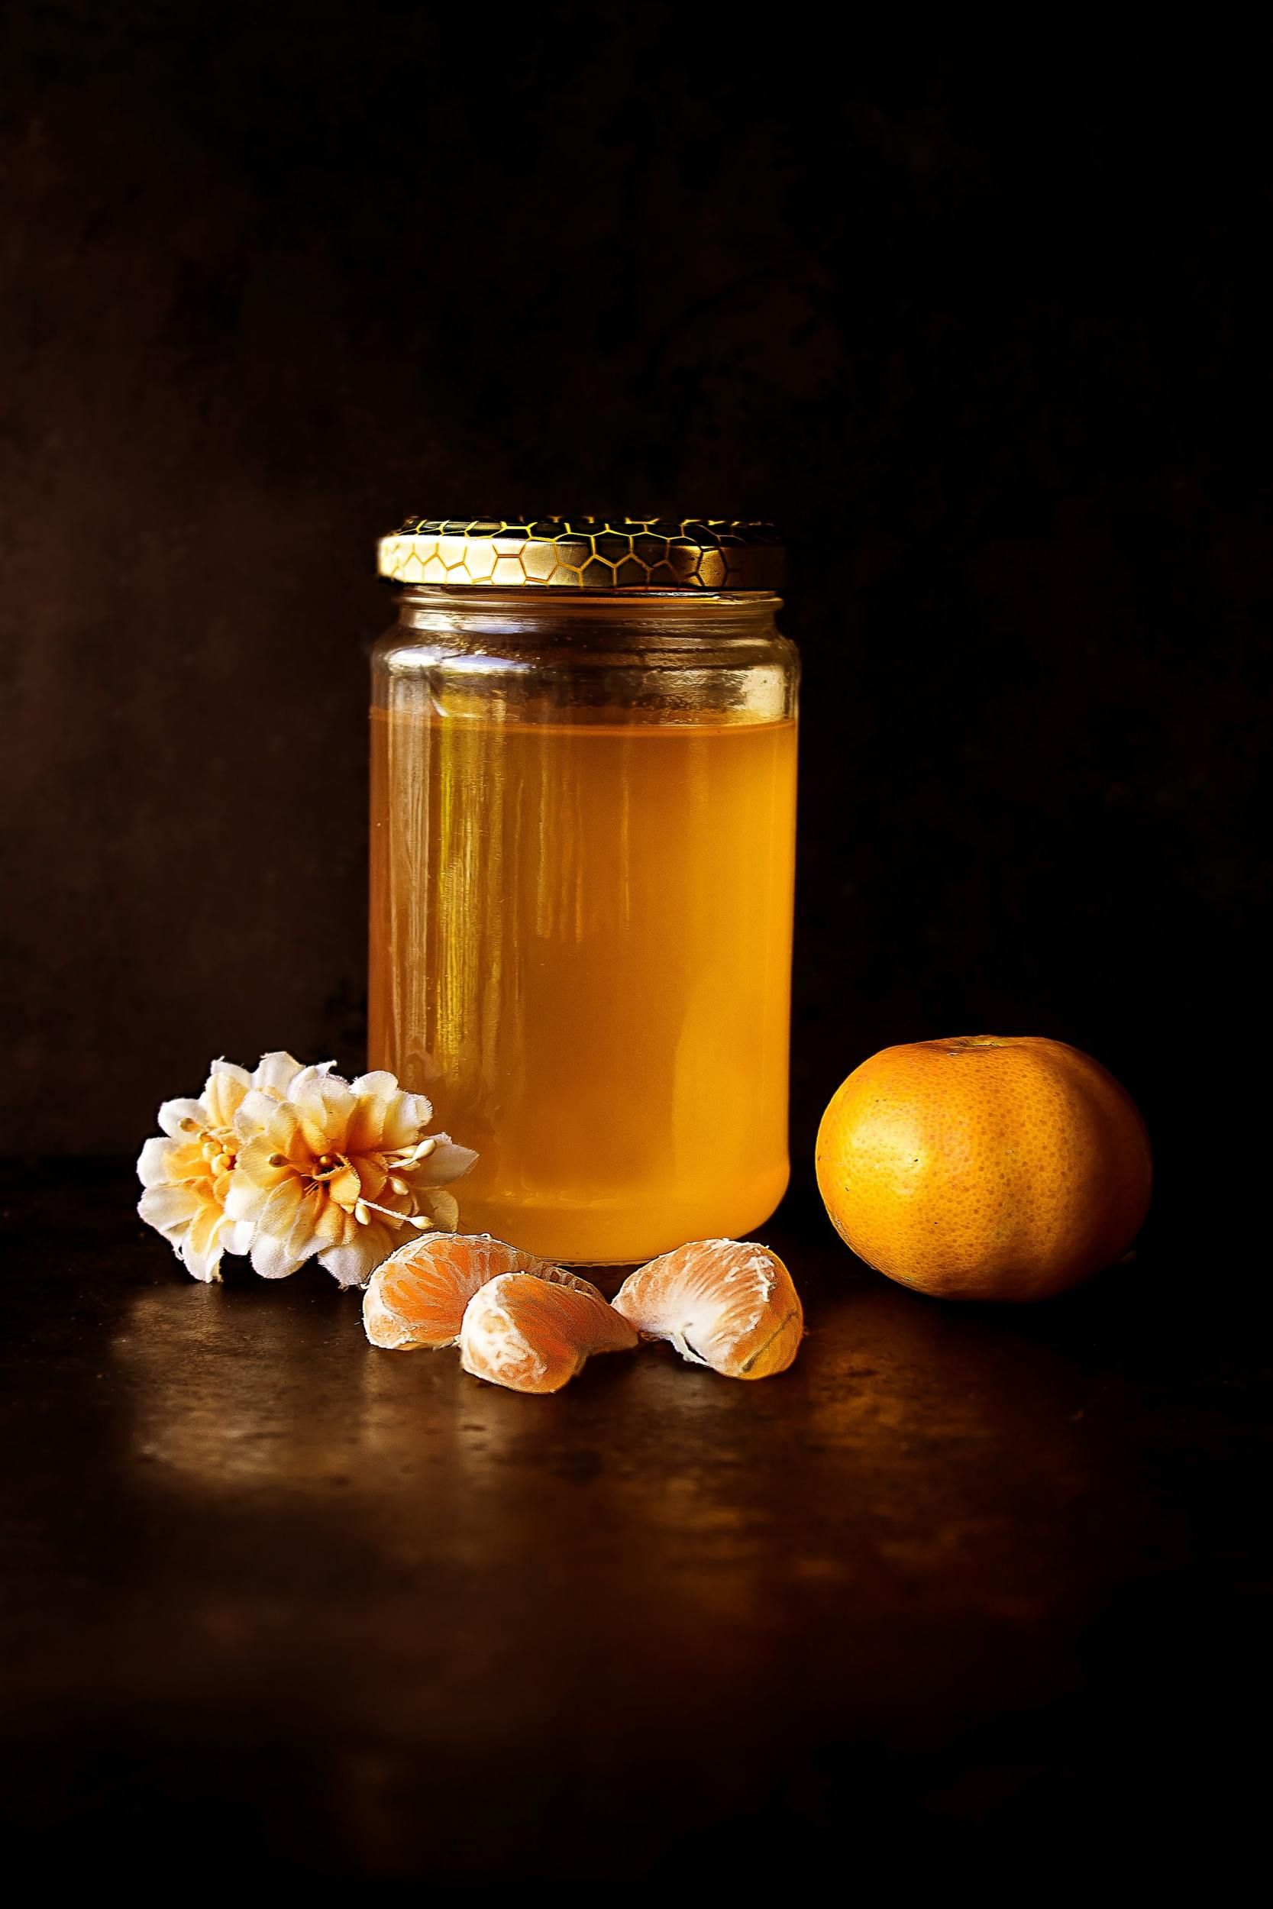

The scene I have chosen is an image of four objects- a jar of honey, a mandarin, mandarin slices, and flower heads. All of these objects will be replicated in the 3D environment. The first thing created in 3D will be a plane for all of the other objects to sit on. The jar of honey will be made with three different sized cylinders- a large one for the main body of the jar, a smaller one with a smaller circumference for the top of the jar’s body, and then another small one with the same circumference of the jar’s main body to act as the lid. The mandarin can be replicated with a sphere, although it may have to be flattened out a little into an obloid to more accurately capture the fruit. The mandarin slices in their base form are essentially a prism, but I would need to make one of the points into a curve to more accurately represent the slices. Finally, the flowers will be the most difficult objects to recreate. My current idea for them is to start with a sphere to represent the main body, and then add cones around it to represent the petals. I will need to be careful with the cone placement to avoid my flowers looking like spiked balls.